BIO 101 LAB O4: Prokaryotes and Eukaryotes Worksheet

Institutional Affiliation
Professor’s Name
Student Name
Course Name
Date

BIO 101 LAB O4: Prokaryotes and Eukaryotes Worksheet
Data Analysis and Synthesis Questions

Table 1: drawings/Observations of Bacterial Shapes
B | C | A
Coccus | Bacillus | Spirillum

Table 2: Drawings/Observations of Cyanobacteria
D  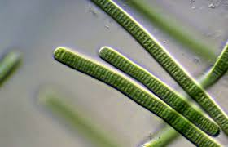 | E  Inside the strands are round balls  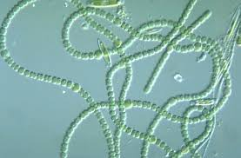
Oscillatoria | Anabaena

1. Nucleoid
2. Observed differences and similarities between the two cyanobacteria samples

Table 3: drawings/ observations of Protists (protozoans)
H  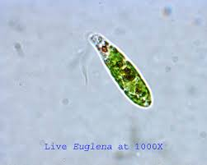 | G  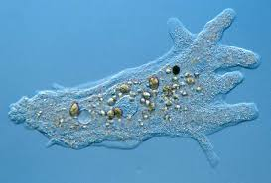
Euglena | Amoeba

F  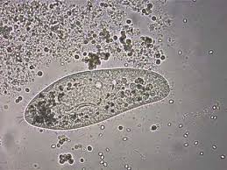 | I  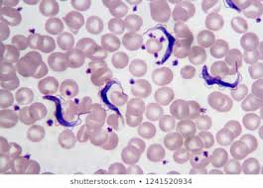
Paramecium | Trypanosoma

Table 4: Drawings/ observations of Protists (algae)
K  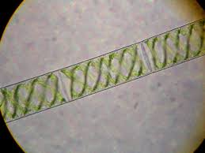 | J  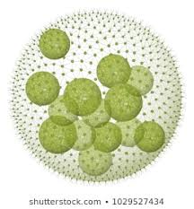 | L  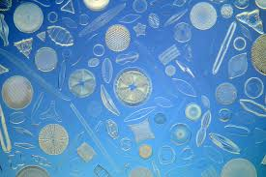
Spirogyra | Volvox | Diatoms

3. The characteristics that differentiate bacteria from Protists
- Bacteria are found everywhere and comprise of a major part of the environment while Protists are found on moist surrounding.
- Bacteria are single-celled organisms with a simple cell structure, without a nucleus hence are prokaryotic organisms while Protists are either single or multi-cellular containing a nucleus and complex cell structure containing all organelles and DNA.
- Bacteria belong to Kingdom Monera while Protists are from Kingdom Protista
- Bacteria are easy to classify due to their natural existence, while Protists are hard to classify due to their characteristics similar plant, animal and fungi.
4.
Table 5
Eukarya  Volvox, Euglena, Giardia, | Archaea  Methanogens, Halobacterium | Bacteria  Anabaena, E. coli

5. Fill in the blanks with plant cell, animal cell, or bacteria cell.
A. Bacteria cell
B. Bacteria cell
C. Animal cell
Table 5: drawings/ observations of Fungi
M  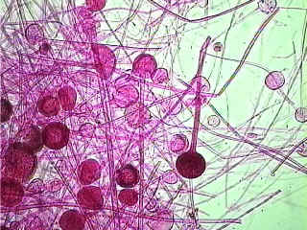 | N  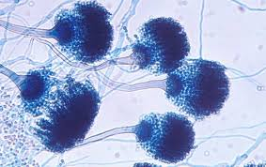 | O  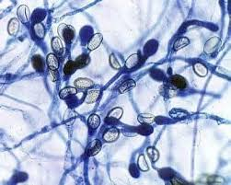
Rhizopus | Aspergillus | Chytrids

6. Three things all fungi have in common
- They lack chlorophyll
- They are consumers and have cell walls
- They have heterotrophic eukaryotic cell structure
7. Fill in the blanks with Ascomycota, Zygomycota, or Chytridlomycota.
a. Zygomycota
b. Ascomycota
c. Chytridlomycota
d. Ascomycota

